Screenshots

- Initial Form – before entering information.
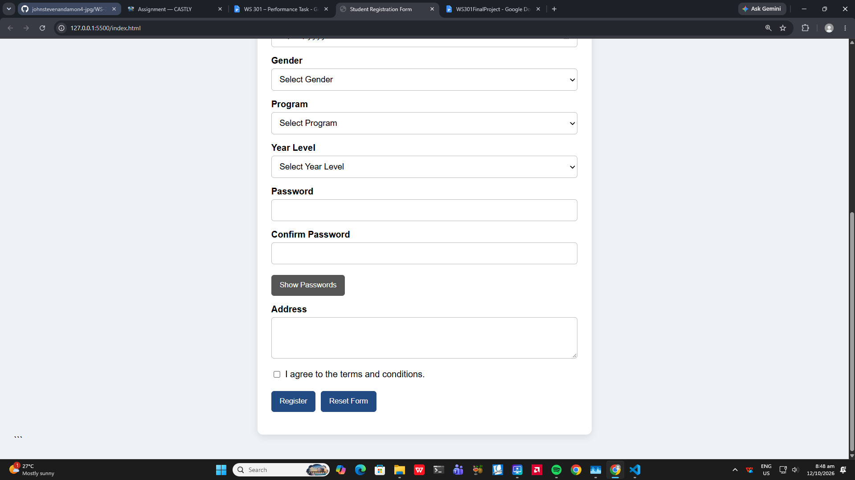
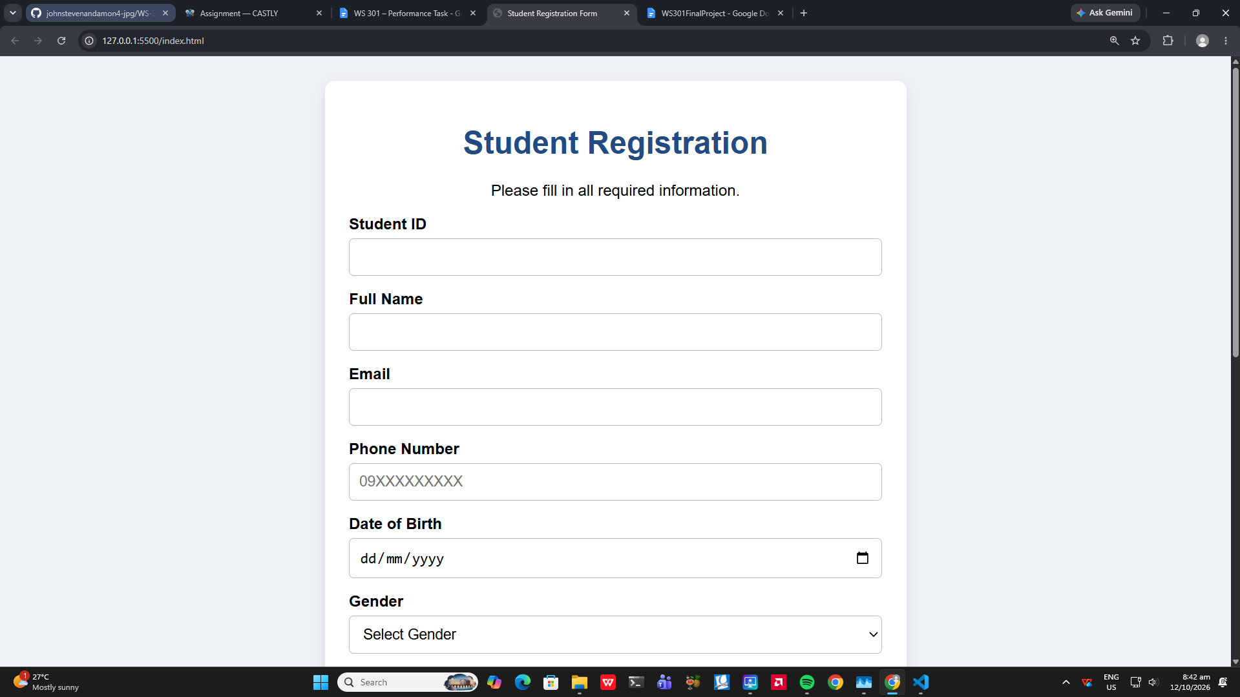

- Validation Errors – showing incorrect or incomplete information.
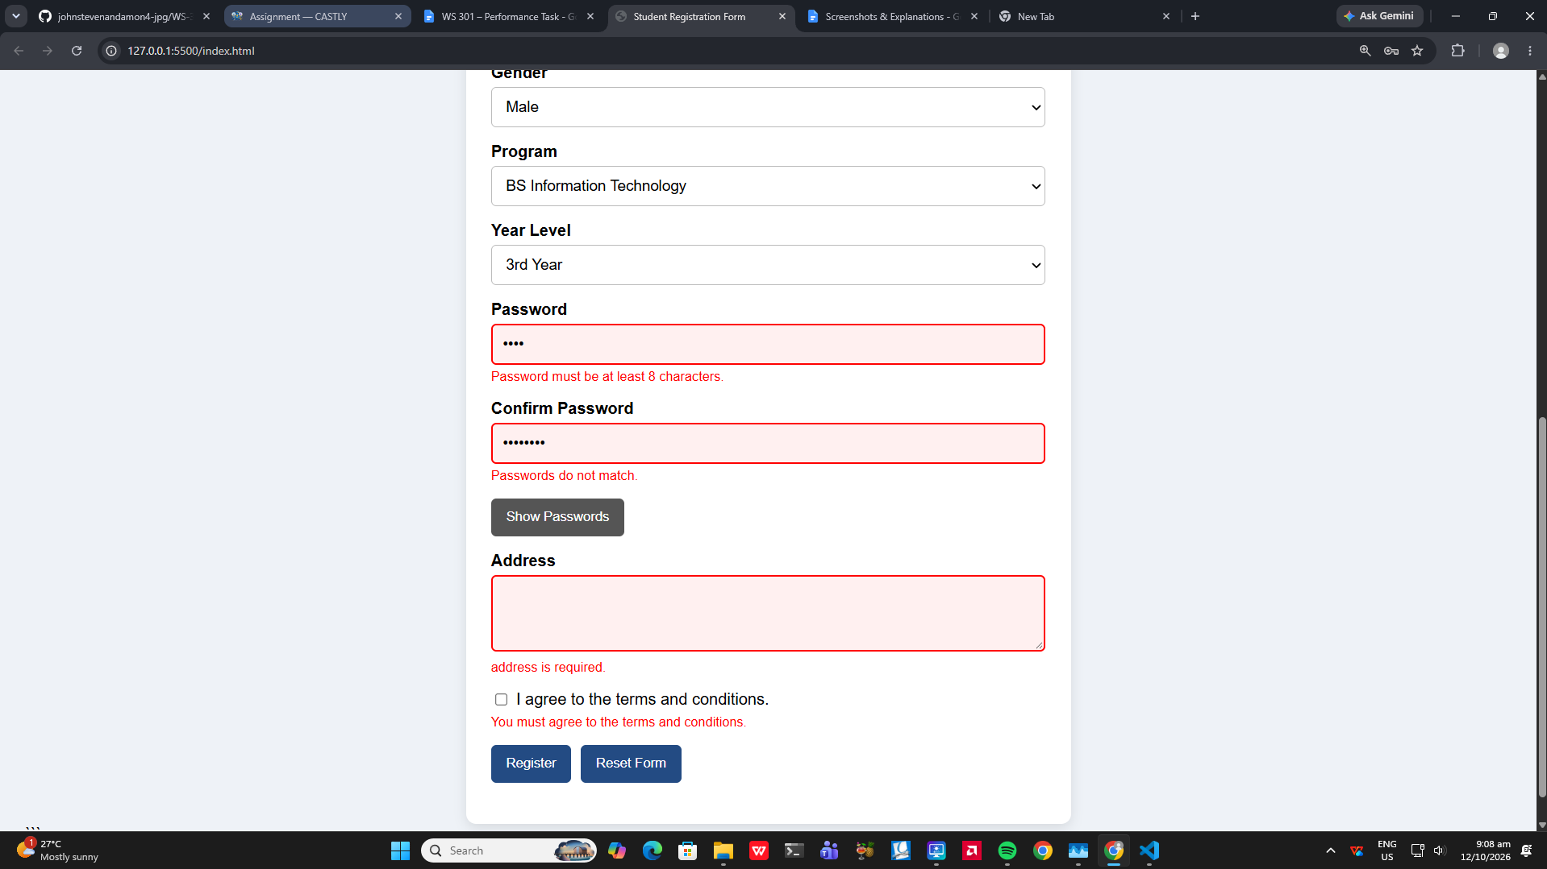
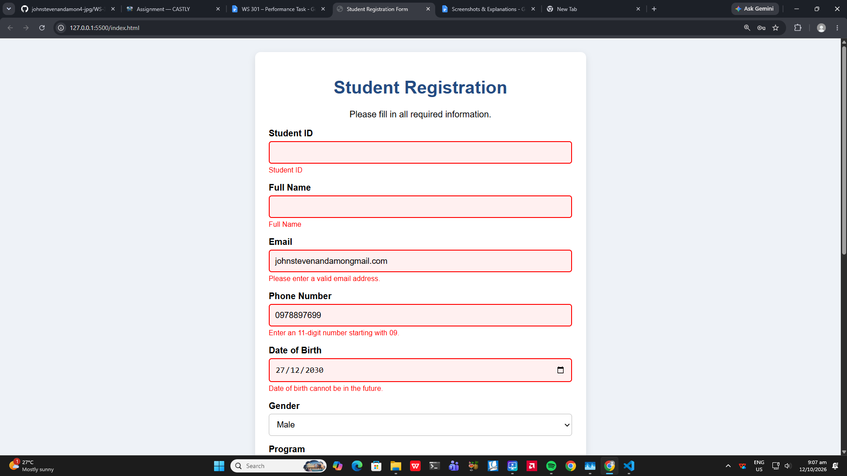

- Corrected Form – showing errors being corrected.
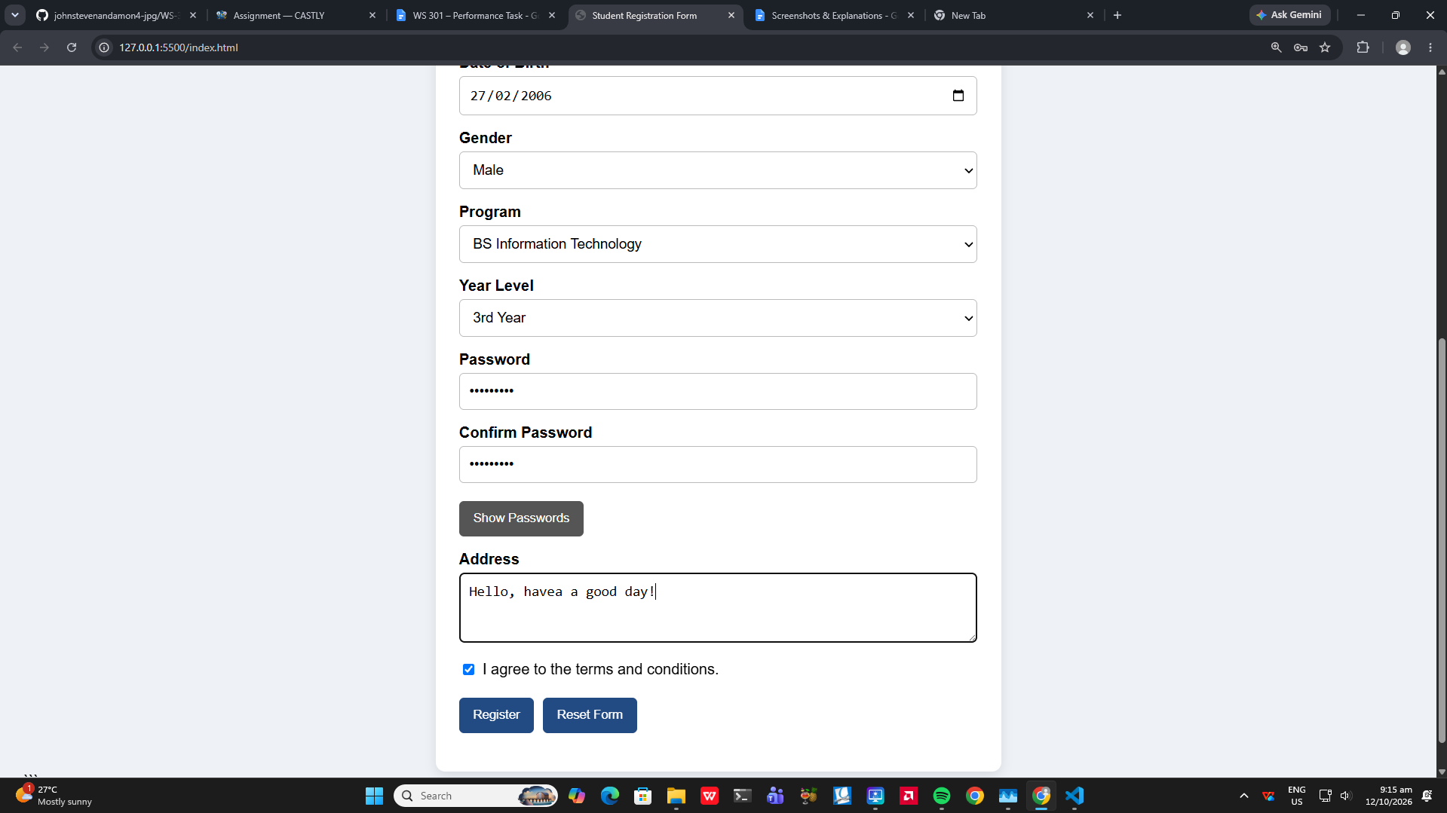
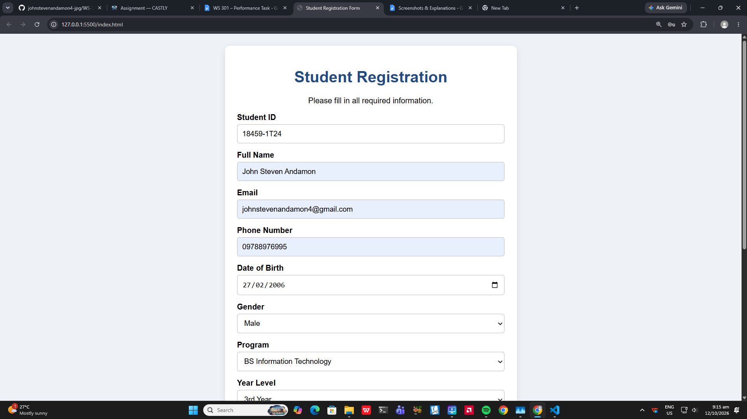

- Successful Form – showing the success message.
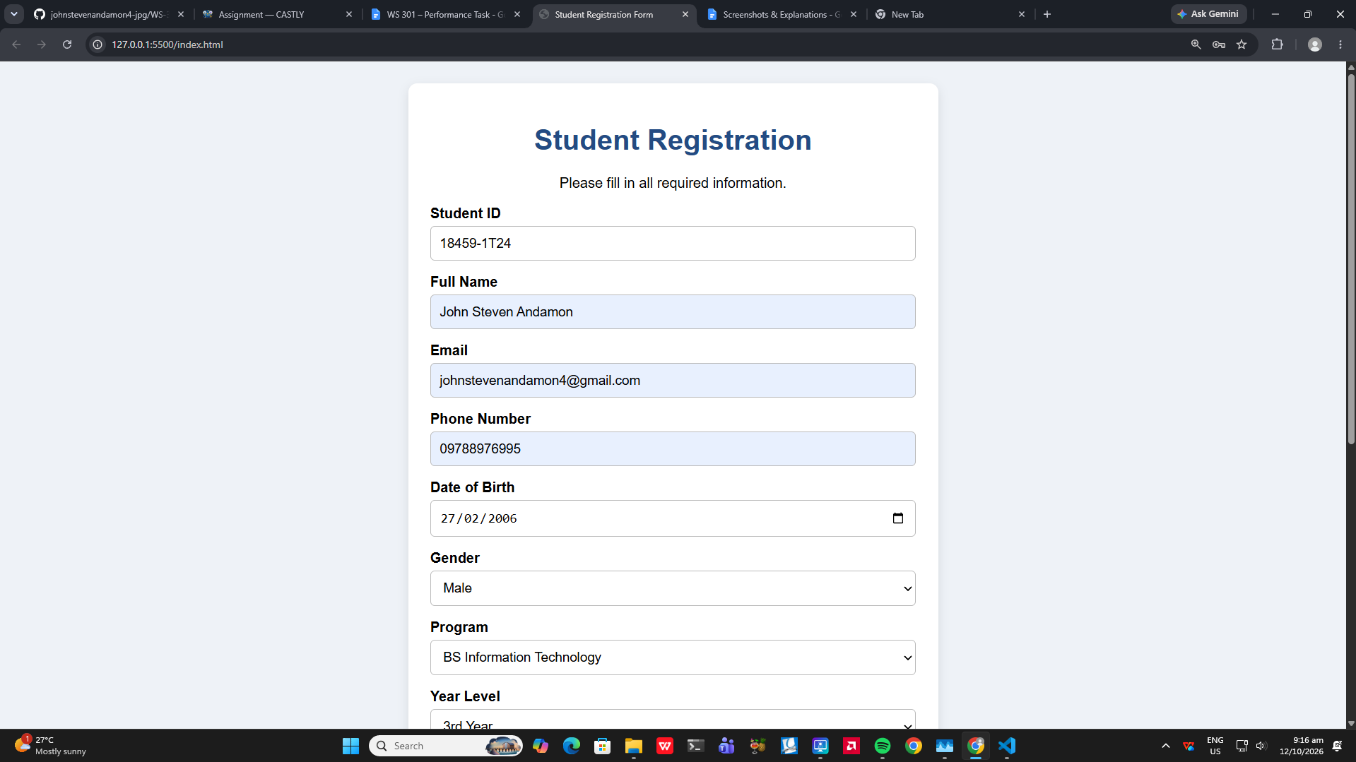
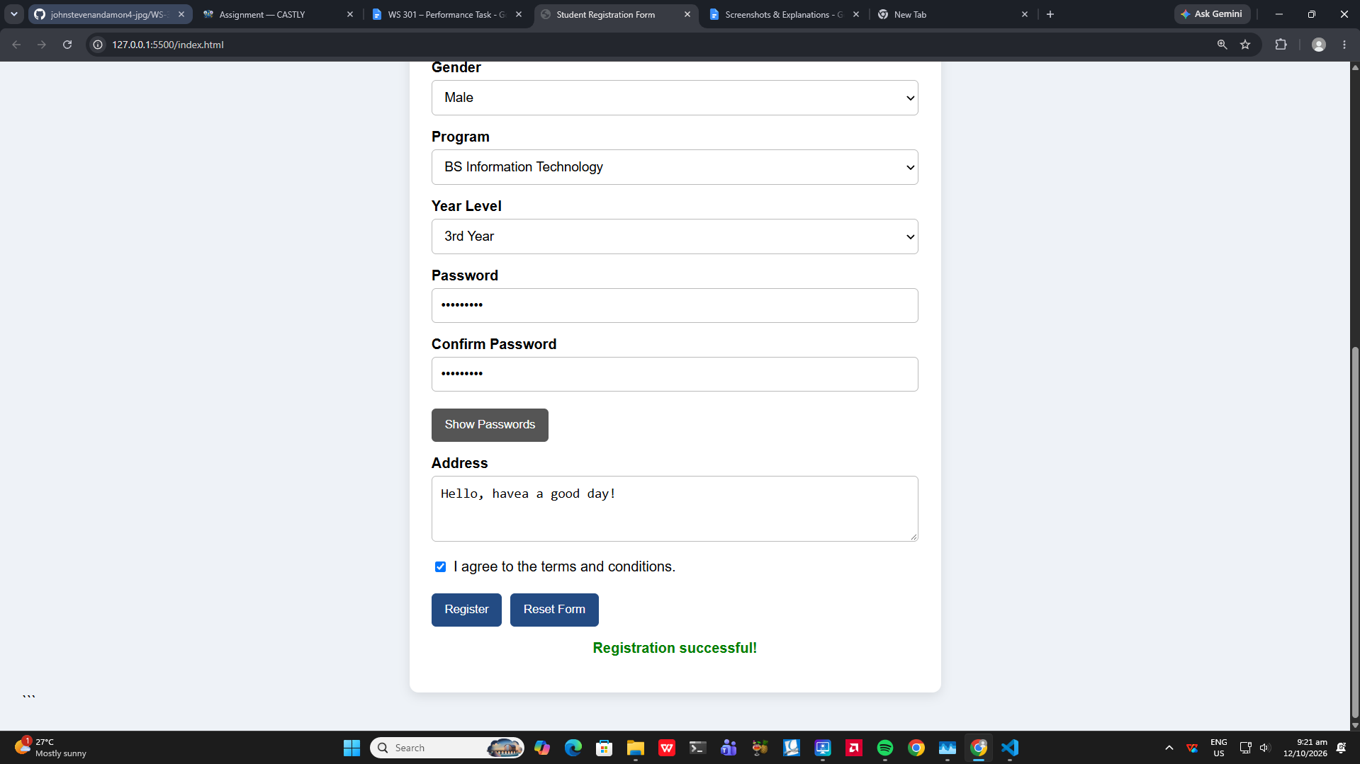

Explanation of the Student Registration Form
- The Student Registration Form allows users to enter their student ID, personal information, contact details, program, year level, password, and address.
- I used JavaScript form validation to check required fields, email format, phone number format, date of birth, password length, matching passwords, and the agreement checkbox.
- I used addEventListener("submit", function(event) { ... }) to handle form submission and event.preventDefault() to prevent the form from submitting normally while the validation checks are performed.
- I displayed specific error messages beside invalid fields to help users identify and correct their mistakes.
- I used classList.add() and classList.remove() to apply and remove the error CSS class, which highlights invalid fields.
- I used classList.toggle() to support the Show Passwords and Hide Passwords feature.
- I added custom data-* attributes to HTML elements and accessed their values using JavaScript's dataset property.
- I used setAttribute() to change the password fields' type attribute between password and text, allowing users to show or hide their passwords.

